# Pork - pasture-raised and organic products

Here is a list of popular brands offering pasture-raised and organic pork:

1. **Elmwood Stock Farm**
2. **Primal Pastures**
3. **Crowd Cow**
4. **White Oak Pastures**
5. **US Wellness Meats**
6. **Niman Ranch**
7. **Belcampo Meat Co.**
8. **Tendergrass Farms**
9. **Circle B Ranch**
10. **Heritage Foods USA**

These brands are known for their commitment to high standards in sustainable and humane farming practices.

If you're interested in exploring more brands that offer pasture-raised and organic pork, here are some additional options:

[Sugar Mountain Farm](https://www.google.com/maps/search/Sugar+Mountain+Farm%2C+West+Topsham%2C+VT)

West Topsham, VT

A family-operated farm raising pastured pigs using natural farming methods, focusing on heritage breeds and sustainable practices.

[Wikipedia](https://en.wikipedia.org/wiki/Sugar_Mountain_Farm)

[BP Farms](https://www.google.com/maps/search/BP+Farms%2C+Quincy%2C+MI)

Quincy, MI

Provides 100% organic, non-GMO, pasture-raised pork, emphasizing humane treatment and high-quality feed.

[BPFarms Organic](https://bpfarmsorganic.com/pastured-pork/)

[Prairie Creek Farms](https://www.google.com/maps/search/Prairie+Creek+Farms%2C+Kellyville%2C+OK)

Kellyville, OK

Offers pasture-raised heritage pork, along with other meats, focusing on ethical and sustainable farming practices.

[Prairie Creek Farm](https://prairiecreek.farm/)

[Alderspring Ranch](https://www.google.com/maps/search/Alderspring+Ranch%2C+May%2C+ID)

May, ID

Provides heritage pasture-raised pork, raised on organic pastures without soy or corn, emphasizing humane and sustainable practices.

[Alder Spring](https://shopalderspring.com/collections/heritage-pasture-raised-pork)

[Reber Rock Farm](https://www.google.com/maps/search/Reber+Rock+Farm%2C+Essex%2C+NY)

Essex, NY

Produces pasture-raised pork fed organic grain, along with other farm products, focusing on sustainable and ethical farming methods.

[Reber Rock Farm](https://reberrockfarm.com/store/pastured-pork)

These farms are known for their dedication to sustainable agriculture and humane animal husbandry, providing high-quality pasture-raised and organic pork products.

At Whole Foods Market, you can find a selection of pasture-raised and organic pork products from reputable brands. Here are some options to consider:

**duBreton Organic Ground Pork**Certified organic ground pork from duBreton, known for humane farming practices.

[Whole Foods Market](https://www.wholefoodsmarket.com/product/organic-ground%20pork-b0781373kc?utm_source=chatgpt.com)

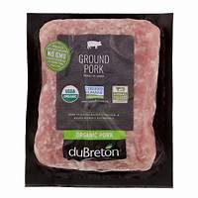

**Thompson Farms Non-GMO Pasture Raised Pork Tenderloin**Pasture-raised pork tenderloin from Thompson Farms, emphasizing non-GMO and humane practices.

[Whole Foods Market](https://www.wholefoodsmarket.com/product/non-gmo-pasture%20raised%20pork%20tenderloin-b07dw86dn2?utm_source=chatgpt.com)

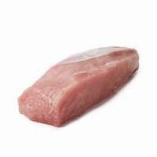

**Wellshire Farms Organic Pork Bacon**Organic pork bacon from Wellshire Farms, offering products free from antibiotics and preservatives.

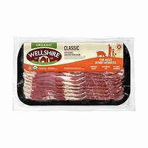

**Niman Ranch Smoked Pulled Pork**Smoked pulled pork from Niman Ranch, known for sustainable and humane farming practices.

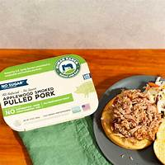

**Whole Foods Market Organic Bone-In Pork Loin Chops**In-house brand offering organic bone-in pork loin chops, adhering to strict quality standards.

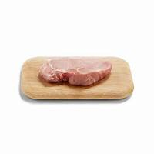

Whole Foods Market maintains rigorous quality standards for all its meat products, ensuring they are free from antibiotics and added hormones, and are sourced from farms that adhere to high animal welfare practices.

[Whole Foods Market](https://www.wholefoodsmarket.com/quality-standards/meat-standards?utm_source=chatgpt.com)

Please note that product availability can vary by location. It's advisable to check with your local Whole Foods Market in Plymouth, Wisconsin, or visit their website to confirm the availability of these products.

At Outpost Natural Foods in Milwaukee, you can find a selection of pasture-raised and organic pork products from reputable sources. Here are some options to consider:

**Beeler's Pure Pork**Beeler's offers pork products from pigs raised without antibiotics or hormones, emphasizing humane and sustainable farming practices.

[Outpost](https://www.outpost.coop/community/vendor/meat-seafood/?utm_source=chatgpt.com)

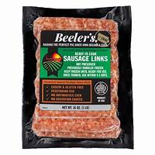

**Niman Ranch**Niman Ranch provides pork from a network of family farmers committed to raising livestock humanely and sustainably, without the use of antibiotics or added hormones.

[Outpost](https://www.outpost.coop/community/vendor/meat-seafood/?utm_source=chatgpt.com)

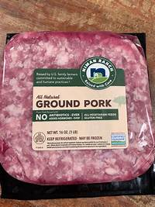

**Outpost's Own Meat Department**Outpost Natural Foods offers in-house, handmade sausages and other meat products, ensuring high-quality standards and transparency about sourcing and production methods.

[Outpost](https://www.outpost.coop/community/vendor/meat-seafood/outposts_own_meat_department?utm_source=chatgpt.com)

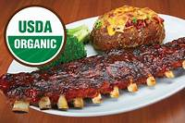

Outpost Natural Foods is dedicated to providing meats that are free from antibiotics, hormones, and growth-enhancing drugs, with a focus on local and regional sourcing whenever possible.